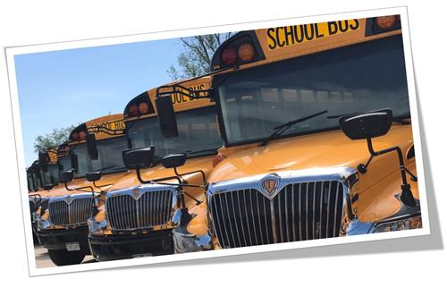­

MyRide K-12 App and RFID Card FAQ’S

* Do I need to create a new account for the My Ride K-12 app or webpage?
  + No. If you have already created an account through Ride360 you will use the same user name and password.
* My student has lost their bus card. How do I order a new one?
  + Please have your student let their bus driver know that they need a new card and the driver will order a card replacement.
* The app shows that my student should be dropped off at 2:47pm, but when I get there at that time, they have already arrived.
  + Please keep in mind that stop times are estimated. Depending on weather, traffic, or other issues the times may change.  You should always plan on being at the bus stop from the time that their school is dismissed to prevent missing their drop off. The same holds true for morning pickup.  If the app says that your student’s pickup time is 7:32am, remember that means that the bus **leaves** the stop at that time.  Your student should always arrive at the bus stop at least 5 minutes prior to the departure time on the app.
* I don’t see any scans for my student.
  + In the app under **Settings,** there is a toggle switch under **Notification Settings** to **Enable Student Scans**. Please make sure that it is switched to the on position if you would like to receive notifications every time your student scans.
  + Please check with your student to be sure that they have their RFID card and are using it to scan on and off of the bus.  If they have been, then please contact Teresa Peterson at [tpeterson4@cherrycreekschools.org](mailto:tpeterson4@cherrycreekschools.org) or 720-554-4647 and she can help troubleshoot.
* Does my student need a new card when they change schools? Do they need a new card every school year?
  + The answer is no and no!  We are very pleased to let you know that the card is assigned to your student and will move with them whether they change schools or grades.  No need to order new ones every time!
* Can I hole punch the card and put it on a lanyard?
  + We ask that you do not alter the cards in any way as it can damage it and make it unusable.
* The bus driver would not let my student ride today because they didn’t have their card.
  + Our drivers make every effort to allow for occasions when a student may forget their card. If a student habitually forgets or willfully refuses to use it, then they may be refused transportation and disciplinary action may be taken.

* We live 1.8 miles from Eaglecrest and my student doesn’t want to walk to school in the cold, so they hop on the bus nearest to our house.  This has never been an issue in the past, but now the driver is saying that they cannot ride.
  + Per Board Policy students are not provided transportation if they live within 2 miles for high school, 1.5 miles for middle school and 1.0 miles for elementary school.  We cannot make exceptions to this.  Routes are built based on these guidelines and buses and drivers are assigned accordingly.